**Subject Property**: Lot No. 550, Village No.4, Sangkat #4, Khan Mittapheap, Sihanouk Ville.

**Land Area:** 5,032 Sqm

**Buiding Area:** Nil

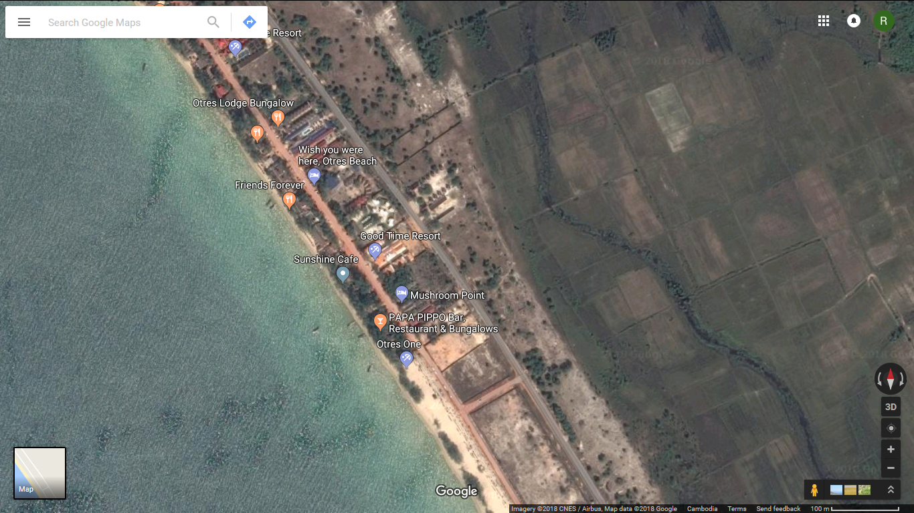

Subject Property

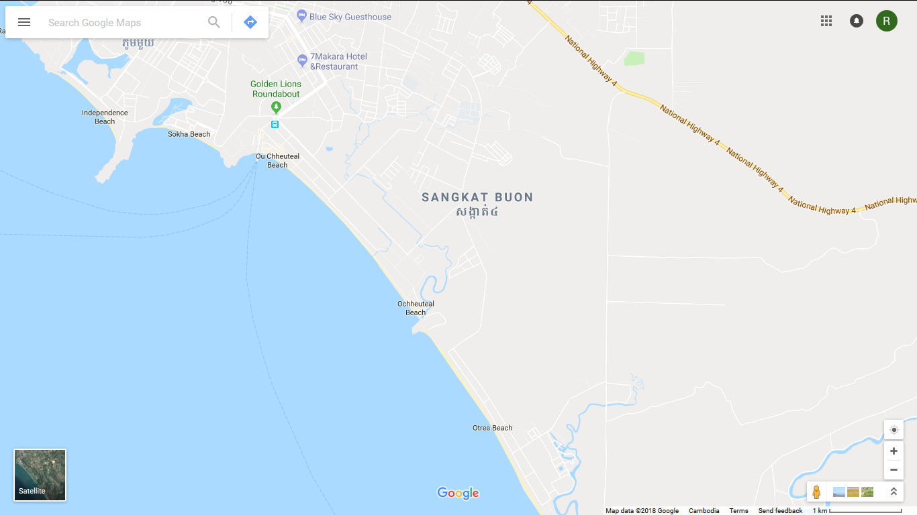

Golden Lion

Subject property

